Xyrus

Your Friendly Virus

Author : John Paul Marte

Date : April 11, 2025

Copyright Information : © 2025 John Paul Marte. All Rights Reserved.

**Document Revision history:**

|  |  |  |  |
| --- | --- | --- | --- |
| Version | Date | Author(s) | Changes |
| 0.1 | Jan . 18, 2025 | Paul Marte | Initial GDD |
| 0.2 | Feb. 14, 2025 | Paul Marte | Draft 2 |
| 0.3 | Apr. 11, 2025 | Paul Marte | Final Draft |

*(Use word’s “update table of contents” to generate / regenerate a table of contents. )*

Table of Contents

1. Section I - Game Overview 5

1.1. Game Concept 5

1.2. Design History 5

1.3. Feature Set 5

1.4. Genre 5

1.5. Target Audience 5

1.6. Game Flow Summary 5

1.7. Look and Feel 6

1.8. Project Scope 6

1.8.1. Number of locations 6

1.8.2. Number of difficulties 6

1.8.3. Number of NPC’s 7

1.8.4. Number of weapons 7

2. Section II - Gameplay and Mechanics 7

2.1. Gameplay 7

2.1.1. Game Progression 7

2.1.2. Mission/challenge Structure 7

2.1.3. Puzzle Structure 7

2.1.4. Objectives – What are the objectives of the game? 8

2.1.5. Play Flow – How does the game flow for the game player 8

2.2. Mechanics 8

2.2.1. Physics 8

2.2.2. Movement 8

2.2.3. Objects 9

2.2.4. Actions 9

2.2.5. Combat 11

2.2.6. Economy 11

2.3. Screen Flow 11

2.3.1. Screen Flow Chart 11

2.3.2. Screen Descriptions 16

2.4. Game Options 17

2.5. Cheats and Easter Eggs 17

3. Section III – Story, Setting and Character 17

3.1. Story and Narrative 17

3.1.1. Back story 17

3.1.2. Plot Elements 17

3.2. Game World 17

3.2.1. General look and feel of world 17

3.3. Characters 17

3.3.1. Character #1 17

3.3.2. Character #2 18

4. Section V - Interface 19

4.1. Visual System 19

4.1.1. HUD - What controls 19

4.1.2. Menus 19

4.2. Control System 20

4.3. Music 20

4.4. Sound Effects 20

5. Section VI - Artificial Intelligence 21

5.1. Opponent AI 21

5.2. Enemy AI 21

6. Section VII – Technical 21

6.1. Target Hardware and operating system 21

6.2. Supported game controllers and peripherals 21

7. Section VIII – Game Art 21

7.1. Concept Art 21

7.2. Characters 22

7.3. Environments 22

7.4. Equipment 22

# Section I - Game Overview

## Game Concept

**Xyrus**, Your Friendly Virus is a fast-paced, top-down 2D arcade game where players control a friendly virus named Xyrus. The goal is to immunize the areas to make them immune to harmful viruses while avoiding threats like White Blood Cells. Players use strategic movement and unique abilities, such as teleportation, to outmaneuver these threats.

## Design History

Version 1.0 : Core infection and avoidance mechanics established.

Version 1.1 : Progressive spawning of white blood cells

Version 1.2 : Teleportation Slime mechanic & mobility

Version 1.3 : Pre-infection deletion

Version 1.4 : Infection and white blood cell collision

Version 1.5 : Infection to immunity conversion

## Feature Set

Real-time infection mechanics.

Unique teleportation ability using a slime projectile.

Increasing difficulty with more white blood cells and pre-infection clearing mechanics.

Infection to immunity conversion

## Genre

Tactical Arcade/Action Puzzle

## Target Audience

Casual gamers, fans of arcade-style games, ages 10 and above.

Gamers who are in the medical field or bioscience.

## Game Flow Summary

Players control Xyrus using directional keys, strategically infecting areas and avoiding white blood cells. The teleportation slime adds a layer of strategic mobility. White blood cells introduce additional challenges by clearing the pre-infection area. Players win by reaching a percentage of immune areas based on the difficulty of the game selected, and lose if there are no more lives left. Lives are deducted when colliding with white blood cells and the countdown timer reaches zero.

## Look and Feel

Biological, with stylized representations of white blood cells and viruses. Lighthearted and fast-paced. Minimalist with vibrant colors to represent infection zones, hazards, and player actions.

`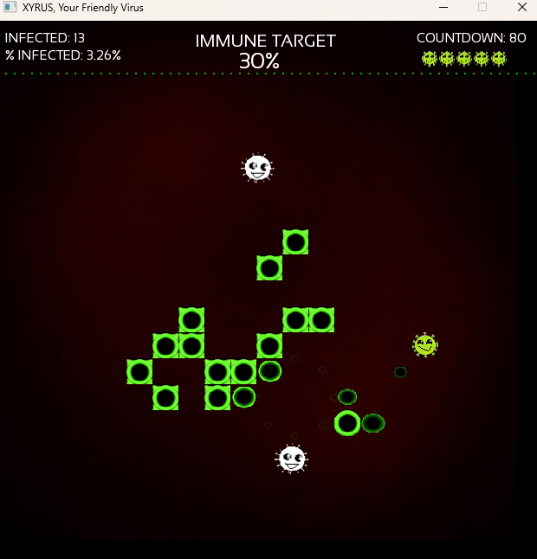

## Project Scope

### Number of locations

Single "window" environment.

### Number of difficulties

Three challenging difficulties.

Easy

Target Immune Coverage: 30%

WBC Speed: Random between 70 – 120

Medium

Target Immune Coverage: 35%

WBC Speed: Random between 100 – 150

Hard

Target Immune Coverage: 45%

WBC Speed: Random between 100 – 200

### Number of NPC’s

None (hazards are non-sentient objects).

### Number of weapons

None

# Section II - Gameplay and Mechanics

## Gameplay

### Game Progression

Xyrus, initially spreads rapidly across the map, infecting most areas with ease. However, as the game progresses, containment measures begin to limit Xyrus's mobility, restricting the free movement of Xyrus and making it harder to maintain control over infected zones. This growing resistance introduces a layer of tactical depth, requiring players to think several steps ahead to avoid losing ground.

To intensify the challenge, a survival timer adds constant pressure: every 90 seconds, Xyrus automatically loses a life, regardless of its current situation. This mechanic introduces urgency and forces players to balance offense and defense, expanding quickly while also preserving their limited lives.

Players must therefore make strategic decisions on when to push for expansion, when to retreat, and how best to navigate the increasingly hostile environment. Mastery involves timing and territory management.

### Mission/challenge Structure

Infect most areas and make them immune to all viruses. Avoid colliding with confused but friendly white blood cells.

### Puzzle Structure

Strategic placement of infected zones and effective use of teleportation slime to navigate around threats.

### Objectives – What are the objectives of the game?

Infect as many areas as possible and convert them into virus-immune zones. Your mission is to reach the target immune percentage for each difficulties while navigating through the host environment.

Be cautious—white blood cells, though confused and not fully hostile, still pose a threat. Avoid direct collisions with them, or risk losing progress.

Strategize your path, infect smartly, and secure immunity before time—and space—runs out.

### Play Flow – How does the game flow for the game player

Players alternate between infection strategy and quick reflex-based navigation. Each difficulty begins with identifying optimal zones for infection while managing limited time. Once infection begins, players must dodge roaming white blood cells and maintain control of spreading zones. The pace shifts constantly—between moments of careful planning and bursts of high-speed movement—as players adapt to WBC movement and the countdown to immunity goals.

This blend of strategy and agility keeps the gameplay dynamic and engaging, challenging both the player’s mind and reflexes.

## Mechanics

### Physics

White blood cells bounce dynamically off walls, infected and immune areas, with randomized velocity changes.

Slime moves in a straight line toward the clicked position.

### Movement

#### General Movement

Xyrus Movement: Cannot leave the screen boundaries.

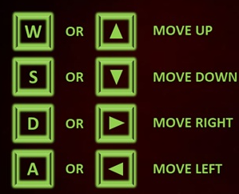

Slime Movement: Fired toward the mouse pointer with a left click.



#### Other Movement

Teleportation: Triggered by pressing 'R' or ‘E’ while the slime is active.



Immunity: Triggered by pressing 'M' while the player is in an uninfected area, then moving away from it.

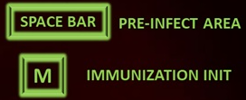

### Objects

#### Picking Up Objects

None

#### Moving Objects

Infected Areas: Created by pressing the spacebar.

Immunity: Created by pressing the ‘M’.

White Blood Cells: Move randomly and bounce off walls.

### Actions

#### Switches and Buttons

Infection: Press spacebar to infect Xyrus's current position.





Immunity: Press M to activate the immunity mechanism on Xyrus's current position.





Slime Firing: Left click to fire slime.



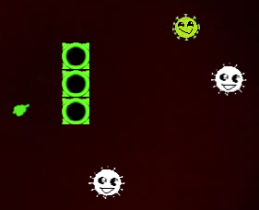

Teleportation: Press 'R' or ‘E’ to teleport to the slime's position.



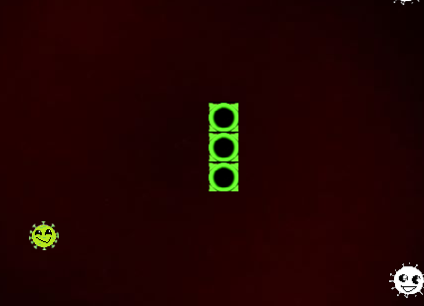

#### Picking Up, Carrying, and Dropping

None

#### Talking

None

#### Reading

None

### Combat

No combat; the challenge is in avoiding hazards and maintaining infection progress.

### Economy

None

## Screen Flow

### Screen Flow Chart

Game Starts with Menu Screen

I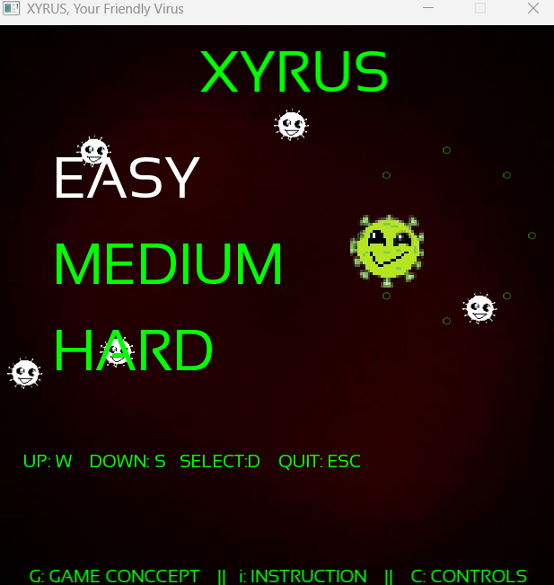

Menu Screen

Press G from Menu Screen to view Game Concept Screen

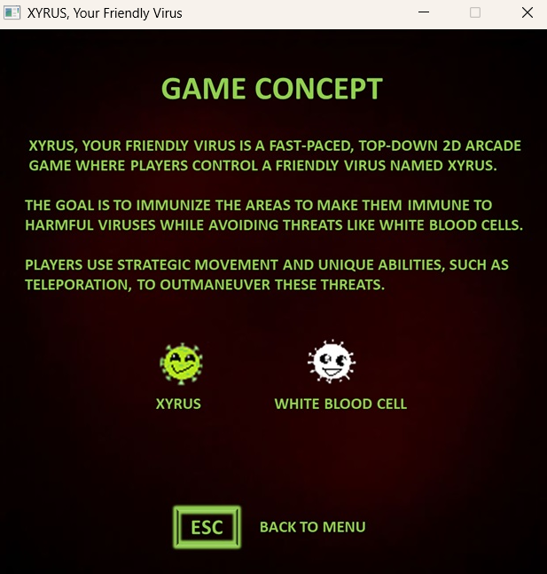

Game Concept Screen

Press i from Menu Screen to view Game Play Instruction Screen

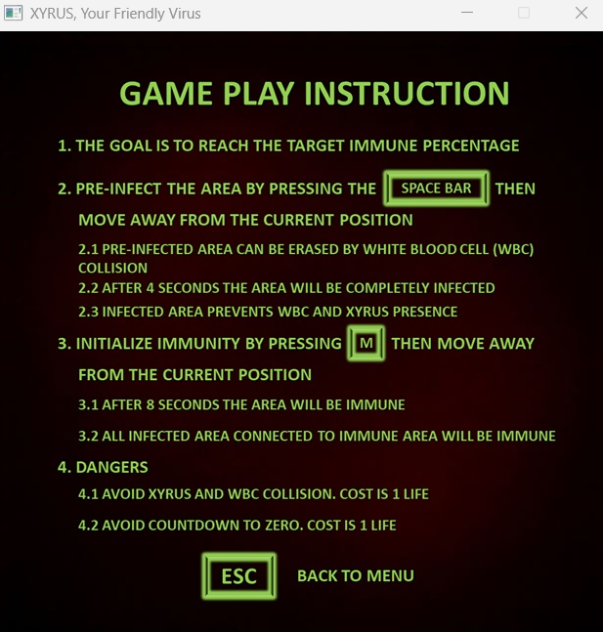

Game Play Instruction Screen

Press C from Menu Screen to view Game Controls Screen

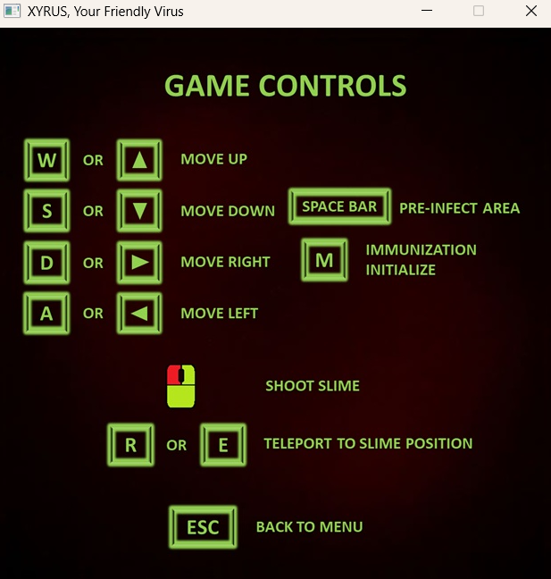

Game Controls Screen

From Menu Screen, press Up and Down Arrow Key to select difficulty then press D to play.

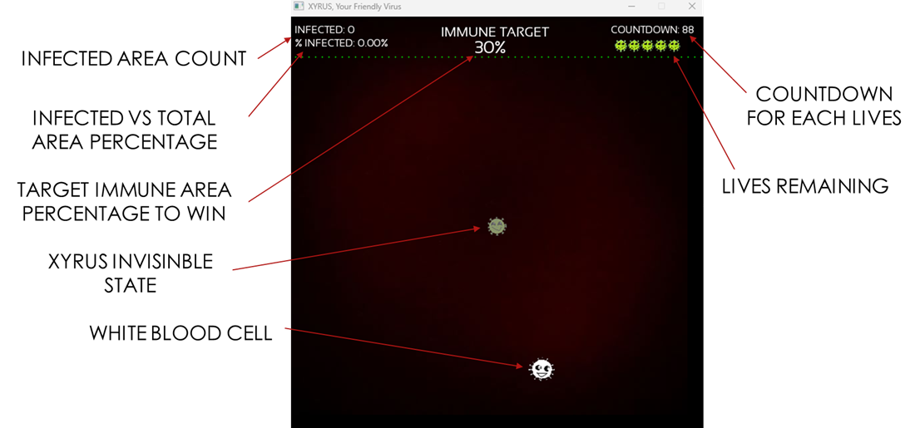

Game Start Screen

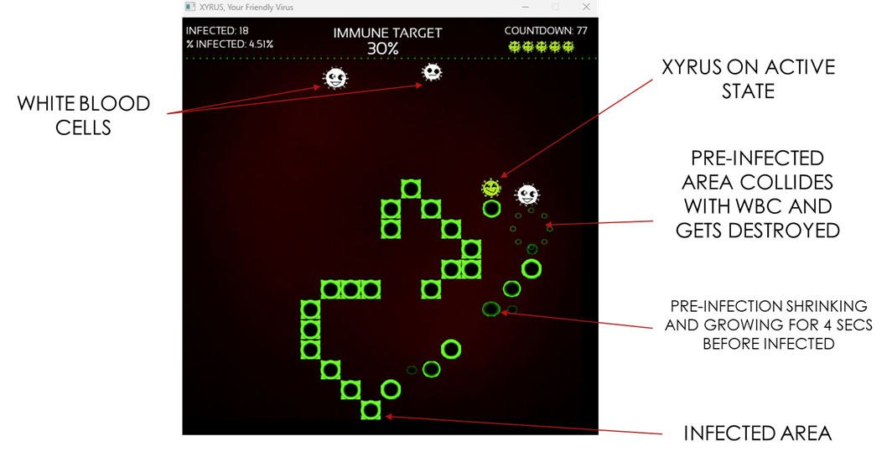

Game Play Screen

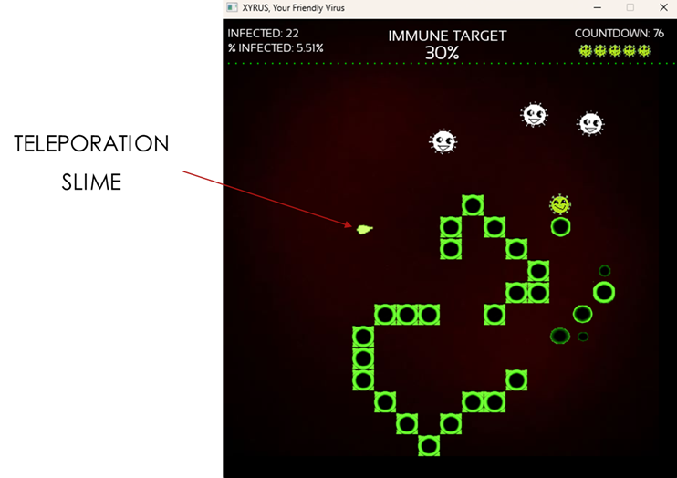

Game Play with Teleporation Slime

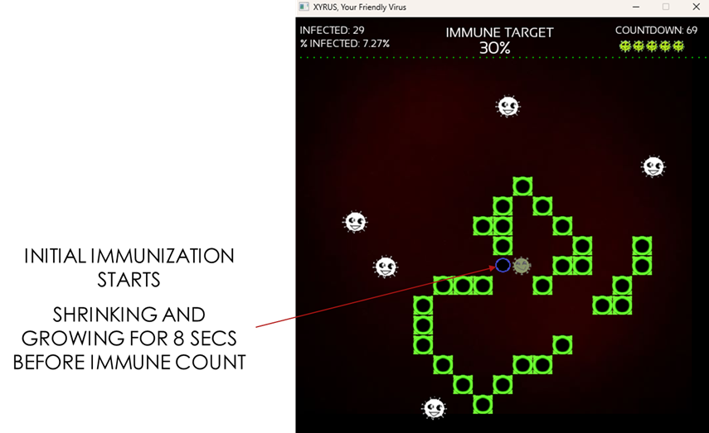

Immunization Initialize

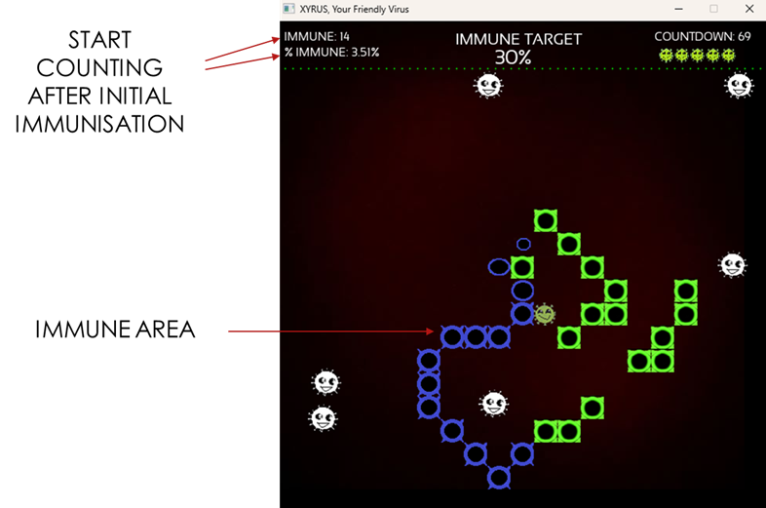

Immunization Counting

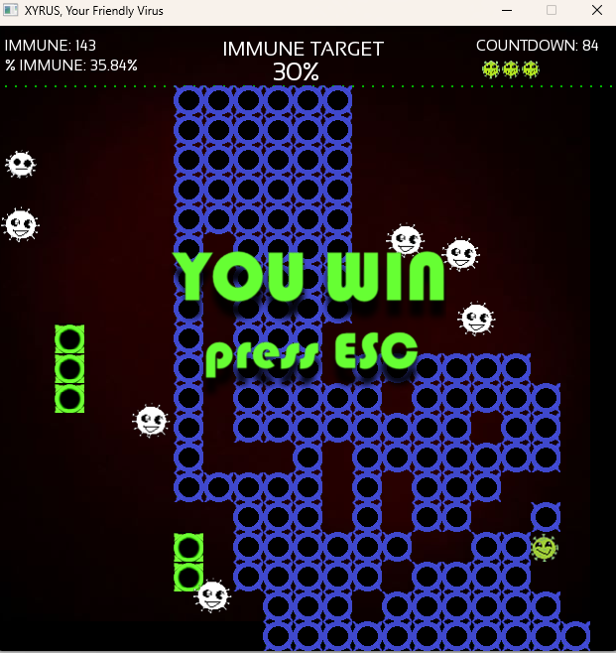

Player Win (Achieving the Immune Target)

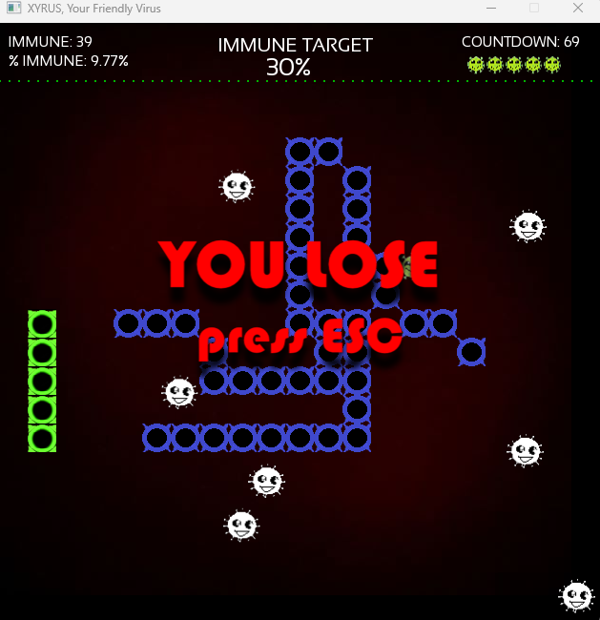

Player Lose (Not Achieving the Immune Target)

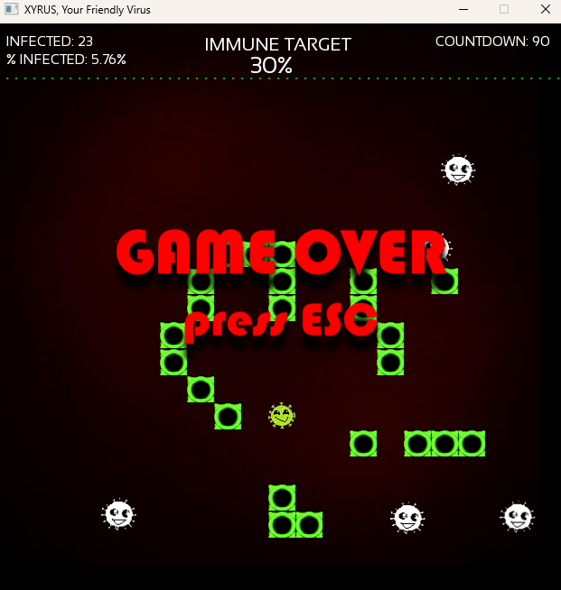

Game Over Screen

### Screen Descriptions

#### Main Menu Screen

Start Game by choosing difficulty easy, medium, and hard, and Exit.

#### Options Screen

Difficulty easy, medium, and hard, and Game Play Instructions and Controls

## Game Options

Easy, Medium, Hard

## Cheats and Easter Eggs

None

# Section III – Story, Setting and Character

## Story and Narrative

### Back story

Xyrus is a rogue virus programmed to protect against harmful pathogens by infecting zones and making them immune. However, the body's defenses view Xyrus as a threat.

### Plot Elements

Progress through increasingly defended area to complete the immunity cycle.

## Game World

### General look and feel of world

A stylized microscopic environment representing a biological cell.

## Characters

### Character #1

#### Back story

Xyrus is a rogue virus programmed to protect against harmful pathogens by infecting zones and making them immune.

#### Personality

Cheerful and determined.

#### Look

A mischievous entity represented as a corona virus look and color green



##### Physical characteristics

Xyrus is a friendly virus with a mischievous smile.

##### Animations

Smiling and Happy

#### Special Abilities

Teleportation slime

#### Relevance to game story

Main character

#### Relationship to other characters

Unwanted by white blood cells

### Character #2

#### Back story

White blood cells are the defenders of the body. It attacks foreign objects that enter the body, i.e., viruses.

#### Personality

Anxious, constantly moving and attacking.

#### Look

An anxious entity represented as a corona virus look and color white



##### Physical characteristics

Corona virus looks and color white

##### Animations

Confused

#### Special Abilities

None

#### Relevance to game story

Defenders of the body

#### Relationship to other characters

Mistakenly treating Xyrus as enemy

# Section V - Interface

## Visual System

### HUD - What controls

Count of infected and immune areas

Countdown Timer

Lives

Immune area over total area percentage



### Menus

Simplistic design focusing on quick navigation.



## Control System

Keyboard inputs for movement, teleportation, and interaction.



## Music

Relax and dynamic.

## Sound Effects

Sound Effects for the following:

Pre-infection

Lose a Life

Move

Shoot a Slime

Teleport

Move or Teleport Rejection

Infection to Immune

Game Win

Game Lose

Game Over

# Section VI - Artificial Intelligence

## Opponent AI

(For future expansion) – Introduce an additional virus with similar spreading abilities as Xyrus but in a harmful way. It competes for territory, overrides pre-infected zones, and reduces Xyrus’s infection stability. Unlike Xyrus, it cannot be controlled by the player and spreads unpredictably, posing a constant threat across the map.

## Enemy AI

(For future expansion) – A rogue virus may appear, capable of destroying both Xyrus and WBC on contact. It relentlessly roams the map, targeting the nearest unit. However, it can be eliminated if it touches Teleportation Slime, which kills and removes it instantly.

# Section VII – Technical

## Target Hardware and operating system

PC / Windows

## Supported game controllers and peripherals

Keyboard and mouse

# Section VIII – Game Art

## Concept Art



Game Screen

## Characters

 

XYRUS WHITE BLOOD CELL

## Environments



BLOOD COLOR

## Equipment

  

TELEPORATION SLIME INFECTED AREA IMMUNE AREA